Day 5: Network Testing Practical

Task 1 :- Connect your laptop and a friend's phone to the same Wi-Fi network, then use the ping command to check if both devices can communicate with each other.

ANS :-

Steps :-

1.Connect both to Wi-Fi :

Make sure your laptop and your friend's phone are connected to exact same Wi-Fi network.

2.Find the phone's IP address :

On phone, go to Settings > Wi-Fi, tap the connected Wi-Fi name, and look for the IP address .

3.Open Command Prompt on your laptop :

Press Windows Key + R, type cmd, and press enter.

4.Run the ping command :

Type ping space and phone's IP address, then press Enter.

For ex:- ping 123.111.222.123

*How to check the result:-

- Connected:

If you see replies like Reply from 192.168.1.15: bytes=32 time=5ms, that means both devices are communicating successfully.

*Here is Practicle screenshot of connected:-

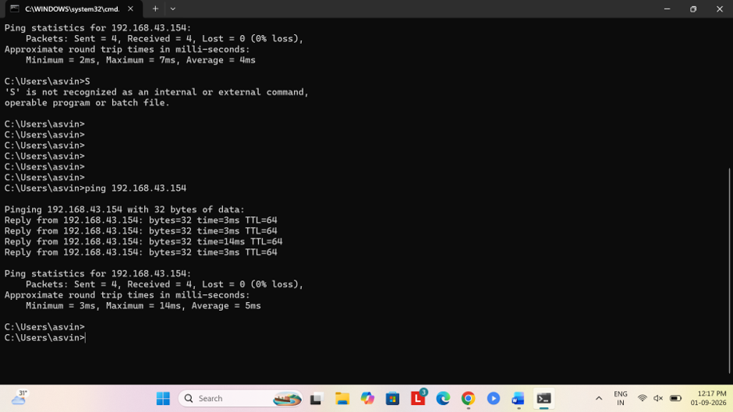

- Not connected :

If you see Request timed out or Destination host unreachable, the devices cannot talk to each other (check if a firewall or "AP Isolation" on the Wi-Fi router is blocking it).

*Here is practical Screenshot of not connected :-

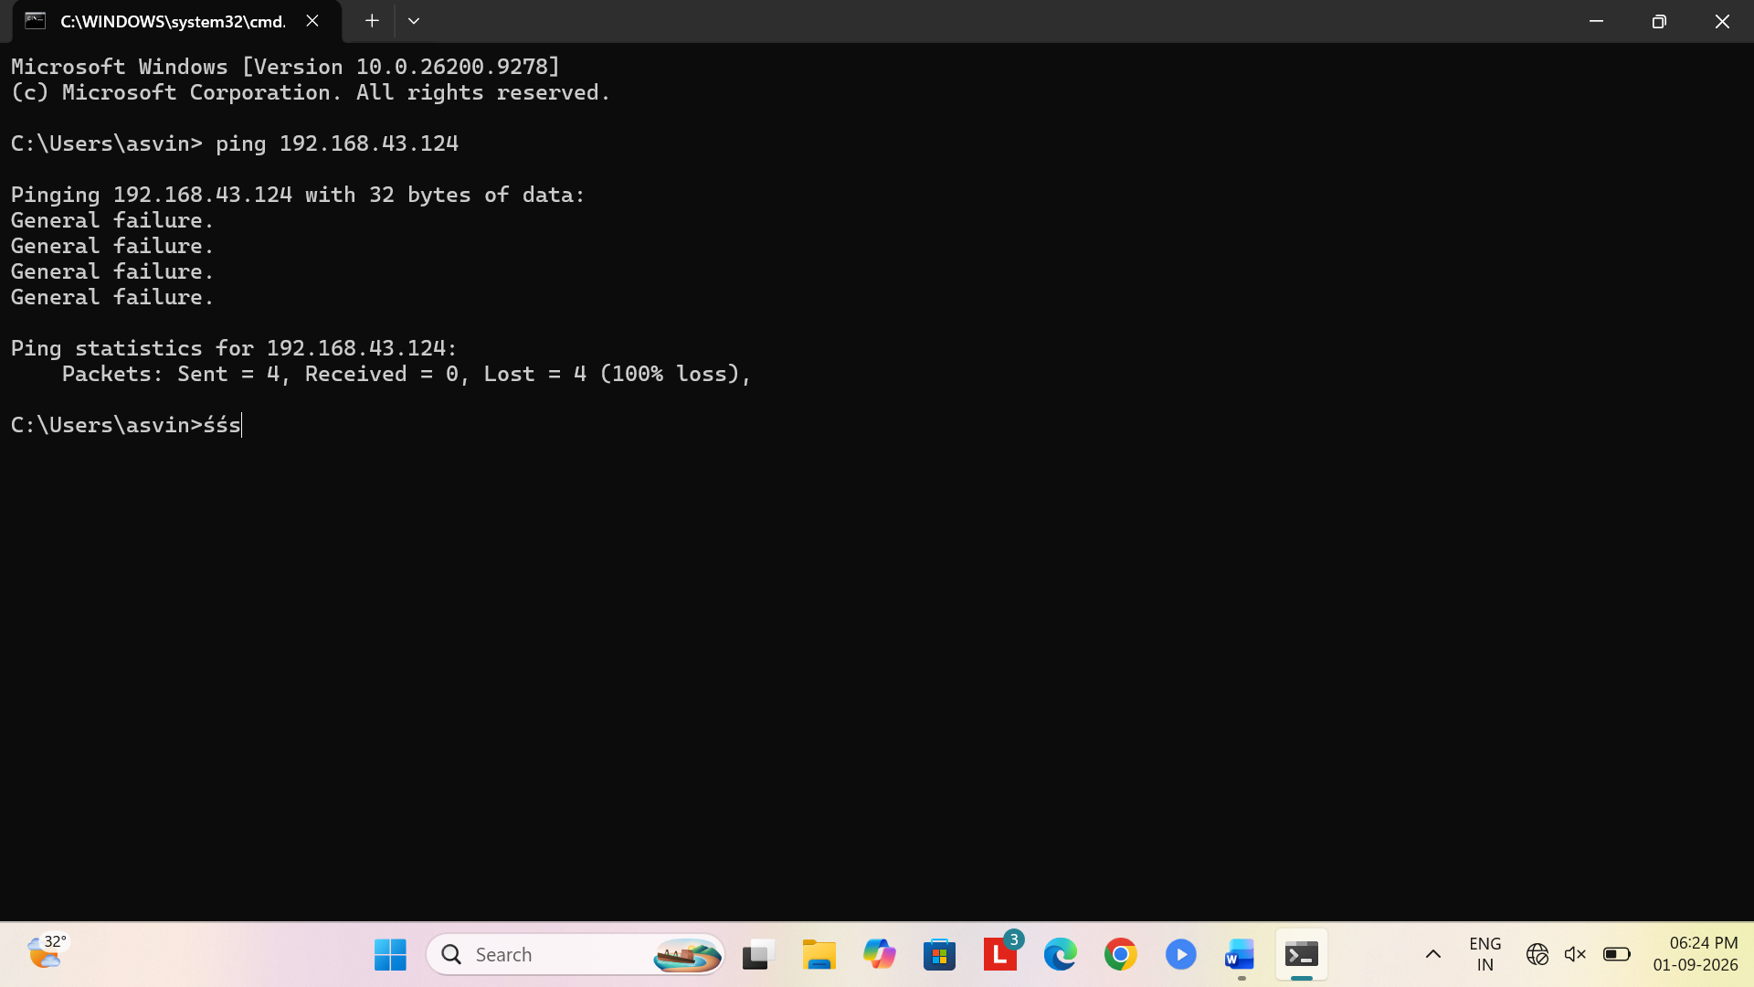

Task 2 :- Run the traceroute (tracert on Windows or traceroute on Mac/Linux) command to www.youtube.com from your device and note down the number of hops it takes to reach the destination.

ANS :-

- Open your terminal :

Press Windows Key + R, type cmd, and press Enter.

2. Run the command:
Type :-
tracert [www.youtube.com](https://www.youtube.com) and press Enter.

*Count the hops :
- You will see a numbered list appear line-by-line (1, 2, 3...).

- Each line represents a "hop" (a router or network stop along the way).

- Once it says Trace complete, look at the last number on the far left. That total number is how many hops it took for your connection to reach YouTube.
Task 3 :- Disconnect one device from the Wi-Fi, then try pinging it again from your laptop and describe the error message you receive.

ANS :-

Error :-

- Request timed out :-
Your laptop sent signals out, but got no response back before time ran out.

- Destination host unreachable :-
Your router has no active pathway or address listed for that device anymore.

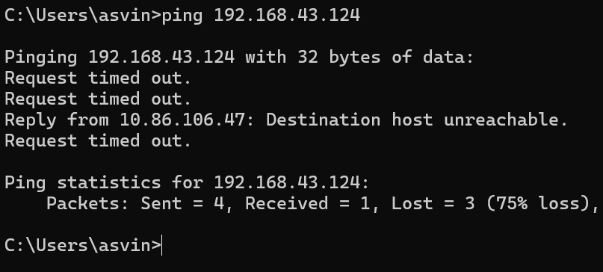
Here Is practical screenshot –

Task 4 :- Create a simple table listing the IP addresses of all devices connected to your home Wi-Fi (use 'arp -a' on Windows), and identify which device belongs to which person or gadget.

ANS :-

1. Open Command Prompt on your Windows laptop (Win + R, type cmd, press Enter).

2.Type arp -a and press Enter.

3.Look at the list under Internet Address to see all active local IP addresses on your Wi-Fi, then match each IP to the corresponding device in your home.

Task 5 :- Write a one-page report explaining step-by-step how you set up the network, tested connectivity using ping and traceroute, and what results or issues you observed.

ANS :-

- Network Setup:-

- Action :
Connected the laptop and a smartphone to the exact same home Wi-Fi network.

- Finding Details :
Opened Wi-Fi settings on the phone to find its assigned IP address (192.168.1.12). Checked connected network devices using the arp -a command on the laptop.

- Connectivity Test (ping):-
- Action :
Opened Command Prompt on the laptop and ran ping 192.168.1.12 while both devices were connected.
(Like win+r then type cmd then enter then type ping 192.168.1.12)

- Result :
Success. The laptop received continuous replies with low latency (under 10 ms), confirming both devices were actively communicating.

- Disconnect Test :
Turned off Wi-Fi on the phone and pinged it again.

- Observed Error :
Received Request timed out and Destination host unreachable because the path to the device was lost.

- Route Tracking (tracert) :-

- Action:-

Ran- tracert[www.youtube.com](https://www.youtube.com) from the laptop to track the path taken across the internet.

- Result :-

Success. The request reached YouTube's servers in 11 hops (routers), starting from the local gateway router (192.168.1.1) out to the internet service provider's network.

*Key Observations & Conclusion :-

- Local Communication:
Devices on the same Wi-Fi can discover and send packets directly to each other when connected.

- Error Behavior:
Disconnecting a device breaks the route immediately, leading to timeout errors.

- External Routing:
Reaching external websites requires multiple hop stops through external ISP routers before arriving at the target destination.

